**UNIVERSITY OF BUEA**



**FACULTY OF ENGINEERING AND TECHNOLOGY**

**DERPARTMENT OF COMPUTER ENGINEERING**

**CEF440: Internet Programming and Mobile Programming**

**COURSE INSTUCTOR: Dr. Valery Nkemeni**

**TASK 2: REQUIREMENT GATHERING**

**BY GROUP 3**

|  |  |
| --- | --- |
| **NAMES** | **MATRICULE** |
| 1. **ABONGWA CALEB NFORNGWA** | **FE22A133** |
| 1. **BEKONO AKONO MARTHE LUNYA LAWRICA** | **FE22A171** |
| 1. **MUKETE ATIA HANS MASANGO** | **FE22A250** |
| 1. **NGUIMFACK AZAFACK JOREL** | **FE22A267** |

**TABLE OF CONTENTS**

Introduction 3

Requirement Gathering 3

What is Requirement Gathering? 3

Requirement Gathering Techniques 3

Requirement Gathering Techniques Used 6

a) Surveys – User Experience Questionnaire 6

b) Interviews – MTN Staff (UB Office) 7

Stakeholder Identification 7

Types of Stakeholders 7

Stakeholders involved with this project 9

Primary Stakeholders 9

Secondary Stakeholders 10

Data Gathering 11

Data Gathering Methods Used 11

Tools and Techniques for Data Collection 12

a. Surveys 12

b. Interviews 12

Document Analysis 12

Challenges Encountered During Data Gathering 13

Key Takeaways 13

Survey responses 13

Data Cleaning 14

Initial Challenges in Raw Data 14

a. Missing or Empty Records 14

b. Inconsistent Labeling 14

c. Overlapping Categorical Entries 14

Detailed Cleaning Procedures 15

a. Column Name Formatting 15

b. Duplicate Responses Check 15

c. Data Typing Validation 15

Insights from Visualization and Cleaning 15

Results Obtained After Visualization 15

Functional Requirements 16

Non-Functional Requirements 17

User Reluctance Assessment 18

Summary 20

Conclusion 20

# Introduction

With the rise of mobile technology across developing countries like Cameroon, mobile network subscribers now expect not just connectivity but **high-quality and consistent service**. From video streaming and gaming to essential services like digital payments and virtual learning, the dependence on mobile data is growing rapidly. However, despite this increasing reliance, users continue to experience issues such as **fluctuating network speeds**, **dropped calls**, **buffering**, and **network unavailability**.

Traditionally, mobile network operators rely on **network-centric metrics**—such as signal coverage, bandwidth, or tower load to assess performance. While valuable, these methods fail to capture the **actual user experience** (QoE), which is subjective and influenced by multiple factors like device condition, usage behavior, and geographic location.

To bridge this critical gap, this project proposes the **design and implementation of a mobile application** that will:

* Collect **real-time feedback** from users regarding their network experience,
* Monitor objective device and network performance parameters passively in the background,
* Log data for analytics to help operators understand how users truly experience their services.

This hybrid approach of combining **subjective user insights** with **objective network data** can help mobile network providers optimize performance, improve user satisfaction, and make data-driven decisions.

# Requirement Gathering

## What is Requirement Gathering?

Requirement gathering is a foundational process in software engineering that involves the systematic collection of information about what a system should do and how it should perform. It includes identifying the expectations, problems, and needs of all relevant stakeholders ranging from end-users to business owners to inform system design and implementation.

**Effective requirement gathering**:

* Ensures that the final product meets user needs,
* Minimizes rework and project delays,
* Identifies functional (what the app should do) and non-functional (performance, usability, etc.) requirements,
* Is achieved through methods such as **surveys**, **interviews**, **observations**, and **document analysis**.

## Requirement Gathering Techniques

Requirement gathering (or requirements elicitation) is the process of collecting the needs, expectations, and constraints of stakeholders in the development of a software system. It is a critical phase in the requirements engineering process because it helps ensure that the final product aligns with the expectations of users, customers, and other stakeholders.

The techniques used for gathering requirements are varied and depend on the type of project, the stakeholders involved, and the available resources. Below is a detailed description of the most common requirement gathering techniques:

1. **Interviews**

**Definition:** Interviews involve direct communication between the requirements engineer and stakeholders to gather their expectations and needs.

**Description:**

* Interviews are typically one-on-one discussions with key stakeholders, such as customers, end-users, or domain experts. The goal is to understand their needs, motivations, and any constraints or challenges.
* Structured interviews follow a predefined set of questions, whereas unstructured interviews are more conversational and allow for more in-depth responses.

**Types of Interviews:**

* **Individual Interviews:** One-on-one sessions to deeply understand individual perspectives.
* **Group Interviews**: A session where multiple stakeholders are interviewed together, encouraging interaction and idea sharing.

**Advantages:**

* Allows for direct interaction and clarification of doubts.
* Provides detailed information and insights from stakeholders.

**Disadvantages:**

* Can be time-consuming and expensive.
* Requires skilled interviewers to guide the conversation effectively.

**2. Surveys/Questionnaires**

**Definition:** Surveys and questionnaires involve distributing a set of pre-designed questions to a large group of stakeholders to gather their requirements.

**Description:**

* Surveys and questionnaires are especially useful when gathering input from a large group of stakeholders or when stakeholders are distributed geographically.
* These tools are typically used to collect quantitative data and can be distributed through email, online forms, or paper-based formats.

**Advantages:**

* Efficient for gathering data from a large group of people.
* Easier to analyze and compare responses statistically.

**Disadvantages:**

* Limited depth in responses, especially with closed-ended questions.
* Risk of unclear or ambiguous questions, leading to inaccurate results.

**3. Workshops**

**Definition:** Workshops involve a group of stakeholders (e.g., users, customers, developers, subject matter experts) who come together to discuss and clarify the system requirements.

Description:

* These are facilitated group discussions designed to extract, discuss, and prioritize requirements.
* Workshops promote collaboration among stakeholders and encourage them to share their views and suggestions.
* A workshop can also include brainstorming sessions, storyboarding, or other techniques to encourage creative thinking.

**Advantages:**

* Promotes collaboration and shared understanding among stakeholders.
* Allows real-time feedback and clarification.
* Provides opportunities for conflict resolution when differing opinions arise.

**Disadvantages:**

* Time-consuming if not well-structured.
* May be challenging to manage large groups with diverse opinions.

**4. Observation (Job Shadowing)**

**Definition:** Observation involves observing users as they perform their tasks in the current system or in their work environment to gather insights into the requirements.

**Description:**

* This technique is especially useful for understanding how end-users interact with the system or process. The requirements engineer watches the users to understand their workflow and identify pain points, inefficiencies, and requirements that users may not articulate easily.
* It can be done in a non-participative manner (just observing) or participative (where the analyst also performs the tasks).

**Advantages:**

* Provides insights into real-world user behavior, often revealing problems that users may not be able to explain.
* Helps uncover tacit knowledge that might be missed in other techniques.

**Disadvantages:**

* It can be time-consuming and expensive.
* Users may alter their behavior when they know they are being observed (observer effect).

**5. Document Analysis**

**Definition:** Document analysis involves reviewing existing documents, such as system specifications, user manuals, and reports, to extract relevant requirements.

**Description:**

* Existing documentation often holds valuable information about the system’s existing state, business processes, and user needs.
* This technique is commonly used when working on legacy systems or improving existing software.

**Advantages:**

* Leverages existing knowledge and documentation.
* Saves time by not requiring direct input from stakeholders.

**Disadvantages:**

* Documents may be outdated or incomplete.
* Can be difficult to extract relevant information if documentation is poorly structured.

**6. Prototyping**

**Definition:** Prototyping involves creating a prototype (a working model) of the system that stakeholders can interact with to provide feedback.

**Description:**

* Prototypes can be low-fidelity (paper-based mockups, wireframes) or high-fidelity (interactive systems or partial implementations).
* The prototype allows stakeholders to visualize the system and provide immediate feedback on its design and functionality.

**Advantages:**

* Provides tangible, visual feedback from stakeholders early in the process.
* Helps clarify ambiguous requirements by allowing users to interact with the system.

**Disadvantages:**

* Developing prototypes can be time-consuming and resource-intensive.
* Stakeholders might focus on minor details rather than the broader requirements.

**7. Brainstorming**

**Definition:** Brainstorming is a group creativity technique where stakeholders generate ideas freely, without judgment or evaluation, to explore potential solutions or requirements.

**Description:**

* Stakeholders are encouraged to express their ideas and suggestions without hesitation. The goal is to generate a wide range of ideas, which can later be refined and prioritized.
* This technique is often used during workshops and meetings.

**Advantages**:

* Encourages creative thinking and idea generation.- Useful for discovering new features or system improvements.

**Disadvantages:**

* Can result in too many ideas, making it difficult to narrow down the most important requirements.
* Requires skilled facilitators to ensure the session remains productive.

There are many techniques available for gathering requirements in software engineering, each with its own strengths and weaknesses. The choice of technique depends on the project’s context, the stakeholders involved, and the resources available. In many cases, combining multiple techniques can lead to a more comprehensive understanding of the requirements and a higher chance of delivering a successful software product.

In this requirement fathering phase of our mobile app we mainly used brainstorming, interviews and surveys since they best suited our project type, resources available and stakeholders involved.

## Requirement Gathering Techniques Used

## a) Surveys – User Experience Questionnaire

We distributed a structured digital questionnaire to collect quantitative and qualitative data from mobile subscribers. Key sections included:

* **Demographics**: Age, mobile phone type, and service provider.
* **Usage Behavior**: Activities like streaming, gaming, social media usage, and frequency of poor network service.
* **Quality of Experience**: Users were asked to rate satisfaction levels for mobile data speed, voice call reliability, and responsiveness.
* **Interest in the App**: Questions evaluated their willingness to install a background monitoring app and preferred features.
* **Concerns and Suggestions**: Open-text fields captured user thoughts on data privacy, usage concerns, and desired functionalities.

This helped identify common user issues and willingness to engage with a solution.

## b) Interviews – MTN Staff (UB Office)

We conducted qualitative interviews with MTN personnel responsible for customer engagement and network support. Insights included:

* **Current Monitoring Techniques**: Use of Market Developers (MDs) to physically map and monitor network coverage and performance.
* **Feedback Channels**: Customers report issues via a WhatsApp chatbot (MTN ZIGI) or by calling 8403.
* **Key Metrics Used**: Signal strength, latency, and service availability were prioritized.
* **Challenges**: Manual methods are time-consuming and cannot address issues at scale due to MTN’s large subscriber base.
* **Concerns About Integration**: The team expressed hesitance to use third-party tools due to **data security risks**.
* **Customer Support**: MTN uses branded mini-stores to address feedback and resolve complaints more directly.

# Stakeholder Identification

Stakeholders are individuals or groups with an interest in an organization's success, categorized as **internal or external** and **primary or secondary** based on their influence and engagement.

## Types of Stakeholders

**1. Primary Internal Stakeholders (Directly involved in operations)**

* **Investors**: Provide financial resources; interested in profitability and growth. Keeping them informed builds confidence.
* **Owners**: Founders or visionaries; their interest in success influences decision-making.
* **Boards of Directors**: Oversee strategic decisions and governance, ensuring alignment with the organization’s mission.
* **Company Leadership**: Managers and executives who implement strategies and shape organizational culture, affecting morale and customer satisfaction.
* **Employees**: Central to operations; their engagement impacts productivity and innovation. Important to maintain morale and trust.

**2. Primary External Stakeholders (Critical external influencers)**

* **Local Communities**: Affected by the organization's economic and social impact; engagement fosters goodwill.
* **First Nations Groups**: Stakeholders in projects on culturally significant lands; engagement must be respectful and transparent.
* **Lenders**: Provide funding; interested in financial security and risk management. Open communication is essential.
* **Regulators and Government Bodies**: Ensure compliance with legal and ethical standards. Monitoring and reporting are crucial for maintaining relationships.

**3. Secondary External Stakeholders (Indirectly affected or influential)**

* **Customers**: Create demand for products/services; their feedback impacts reputation and loyalty.
* **Suppliers and Vendors**: Provide necessary goods/services; stable partnerships benefit both parties.
* **Media Groups**: Shape public perception; maintaining open communication helps manage reputation.
* **Trade Unions and Industry Bodies**: Advocate for employee rights; engaging with them supports positive workforce relations.
* **Interest Groups**: Non-profits focused on specific issues (e.g., environment, human rights) that ensure compliance with regulations and expectations.

**Why Understanding Stakeholders Matters**

Understanding stakeholders is crucial for the success of projects. By conducting a stakeholder analysis, organizations can:

* **Prioritization**: Identify stakeholders with the most interest or influence to focus on their needs and concerns, thereby allocating resources effectively and addressing potential roadblocks early.
* **Communication**: Tailor communication strategies based on stakeholders’ unique interests, ensuring that everyone stays engaged and informed through preferred channels.
* **Understanding Influence**: Analyze how stakeholders influence each other, which helps in navigating the dynamics of support and feedback within the project. When stakeholders feel valued, they are more likely to actively support the project, leading to enhanced collaboration, increased commitment, and smoother execution.

**How to Identify Types of Stakeholders and Their Roles**

The identification process involves four steps:

1. **Identify All Stakeholders**: Create a comprehensive list of all parties influencing or affected by the project.

2. **Determine Criteria**: Prioritize stakeholders based on factors like influence, interest, and impact.

3. **Analyze Stakeholders**: Rate each stakeholder according to the chosen criteria to assess their engagement needs.

4. **Categorize and Rank**: Rank stakeholders by priority to allocate resources effectively. Using stakeholder mapping tools can help visually organize and categorize stakeholders based on their influence, interest, and impact, ensuring that critical relationships receive appropriate attention.

**Tools for Stakeholder Management**

Utilizing tools like Simply Stakeholders can streamline stakeholder management, providing visibility into relationships and enhancing engagement. Features include advanced mapping, relationship tracking, and sentiment analysis, all aimed at fostering meaningful connections. Overall, effective stakeholder management is essential for project success and long-term organizational growth.

## Stakeholders involved with this project

### Primary Stakeholders

These are the key users and beneficiaries who directly interact with the system or whose needs the project aims to fulfill.

#### ****1. Mobile Network Subscribers (End Users)****

Mobile subscribers are the **core target audience** of the mobile app. They are the ones who will:

* Install and use the app on their devices.
* Provide **subjective feedback** about their experiences with mobile network services (e.g., internet speed, call drops, responsiveness).
* Allow the app to collect **objective performance metrics** (e.g., signal strength, ping, bandwidth) in real-time.

Their **feedback, concerns, and level of engagement** will determine the success of the app. User adoption depends heavily on factors such as app usability, transparency, data privacy, and battery efficiency.

#### ****2. Mobile Network Operators (e.g., MTN, Orange)****

These companies are responsible for delivering mobile services and are **indirect beneficiaries** of the system. Their interests include:

* Gaining **deeper insight into users’ quality of experience (QoE)** across different regions and usage contexts.
* Using the gathered data to **optimize network infrastructure**, improve customer satisfaction, and reduce churn rates.
* Ensuring that the monitoring process aligns with their **internal data security policies** and **regulatory compliance**.
* Potentially integrating app feedback into their customer support or network planning operations.

They may also have reservations about **third-party involvement**, making collaboration and transparency critical.

### Secondary Stakeholders

These stakeholders play supportive, advisory, or oversight roles in ensuring the system’s technical, ethical, and regulatory compliance.

#### ****1. Telecommunications Regulatory Bodies (e.g., ART Cameroon)****

Regulators are responsible for **overseeing mobile service standards** and protecting consumer rights. Their roles include:

* Ensuring the project aligns with national telecommunications laws and **data privacy regulations**.
* Using the app's anonymized data to **monitor network operator performance** and enforce service level agreements (SLAs).
* Supporting the development of **evidence-based policies** for improved national coverage and service delivery.

Their endorsement or support could legitimize the project and **boost public trust**.

#### ****2. Mobile App Developers and Engineering Teams****

These are the technical professionals tasked with:

* Designing, developing, and deploying the mobile application.
* Ensuring the app captures both **real-time network data** and **user feedback** accurately.
* Maintaining high standards for **usability**, **performance**, **security**, and **data protection**.
* Iterating on the system based on feedback from users and other stakeholders.

They must also incorporate **privacy-preserving features** such as anonymization, opt-in permissions, and usage transparency.

#### ****3. Researchers and Data Analysts****

This group will be responsible for:

* Analyzing collected data to extract meaningful insights on **network quality and user behavior**.
* Identifying **geographic or time-based patterns** in performance.
* Supporting continuous improvement of the app through **user experience (UX) evaluations** and **trend analysis**.
* Contributing to **academic research** or publishing findings that can influence technology policy or telecom innovations.

Their insights can also be shared with telecom operators to aid in **infrastructure planning** and **service optimization**.

#### ****4. Privacy Advocates and Legal Entities****

These stakeholders are crucial for:

* **Ensuring legal compliance** with local and international data protection laws (e.g., GDPR-like standards).
* Reviewing and guiding the app’s **terms of use**, **consent mechanisms**, and **data sharing policies**.
* Advocating for user rights related to **data ownership**, **transparency**, and **informed consent**.
* Monitoring that the app does not pose legal or ethical risks to users or operators.

Their involvement can help establish **public confidence** and ensure long-term sustainability of the app.

# Data Gathering

**Data gathering** (or **data collection**) is the process of **collecting information** from various sources to **analyze, make decisions, or solve a problem**.

## Why is it important?

* To **identify trends** or patterns.
* To **make informed decisions**.
* To **support research** or investigations.
* To **improve products or services**.

## Data Gathering Methods Used

#### a. ****Online Survey****

A structured questionnaire was developed and distributed digitally to mobile network users in Cameroon. The survey consisted of **15 questions** covering a wide range of topics including:

* Age group and mobile phone type
* Primary mobile network provider
* Purpose of mobile data usage
* Frequency of poor service
* Satisfaction with internet speed
* Voice and online activity reliability
* Willingness to share feedback or install a monitoring app
* Privacy concerns and feature expectations

##### Key Aspects of the Survey:

* Total Responses: 50
* Format: **Google Forms/Excel CSV**
* Distribution: Shared via mobile and online student groups, particularly targeting **youth users** (18–25 years old), as they represent a significant proportion of data consumers.
* Data Format: Responses were downloaded in .csv format for analysis.

#### b. ****Field Interviews at MTN Office, UB****

To complement the survey, on-site interviews were conducted with **commercial workers** at the **MTN Office in the University of Buea (UB)**. These workers interact directly with customers, giving them deep insight into recurring complaints and internal response strategies.

##### Interview Highlights:

* MTN uses **MD mapping tools** to pinpoint and troubleshoot localized signal issues.
* There are approximately **21 antennas** operating in the Buea area.
* Customers with issues can use the **MTN Zigi WhatsApp bot** or dial **8403** to get redirection support.
* **Security is a major concern**, with MTN avoiding third-party apps due to privacy risks.
* Only **top management** is allowed to access or share sensitive user data, limiting the ability of regular staff to address deeper concerns.

## Tools and Techniques for Data Collection

### a. Surveys

Surveys provided scalable and structured data collection. Users could respond at their convenience, and data aggregation allowed us to analyze patterns in user experience.

**Advantages:**

* Cost-effective
* Easy to distribute
* Quick to analyze quantitatively

### b. Interviews

Interviews were semi-structured and provided context to the survey data. These were useful for exploring internal MTN processes, employee insights, and limitations.

**Advantages:**

* Rich qualitative insights
* Clarified organizational procedures
* Captured hidden issues not obvious in survey data

### Document Analysis

We analyzed field notes and user responses to group keywords like:

“Slow”, “Dropped calls”, “Poor network”, “Data privacy”, “Battery drain”, “Real-time”. This helped us refine the requirements and priorities for a monitoring system.

### Challenges Encountered During Data Gathering

* **Limited access to high-level MTN staff**: Many questions related to internal metrics and policies could not be answered during the interviews because only top management has that authority.
* **Survey participation scope**: The survey had a relatively small sample size (47 respondents), which may not fully represent the entire demographic diversity of Cameroon.
* **Reluctance to disclose personal data**: Some users were hesitant to answer questions related to data privacy or app monitoring, even when assured of anonymity.

### Key Takeaways

* A significant portion of users are **dissatisfied or neutral** regarding internet speed and signal quality.
* Most users are **open to providing feedback**, but want control over their **privacy and data usage**.
* MTN staff are aware of infrastructure challenges and use tools like **Market Developers and MTN Zigi**, but lack direct decision-making power.
* Both data sources aligned to show **signal reliability, responsiveness, and data protection** as the top user concerns.

### Survey responses

From the **survey responses**, we noted the following trends:

* **Demographics**: The majority of respondents fell within the 18–25 age group and were mostly Android users.
* **Usage Patterns**: Users heavily depended on mobile networks for **social media**, **streaming**, and **browsing**.
* **Service Issues**: A significant portion of users reported **frequent or consistent poor service**, especially during peak hours.

**QoE Ratings**:

* **Internet speed** was rated “Neutral” to “Dissatisfied” by most respondents.
* **Call reliability** was rated “Average” to “Unreliable”.
* **Responsiveness** of the network when loading apps or pages was a common complaint.

**Interest in the App**:

* **Over 60%** expressed willingness to install the app, with a strong interest in features like **real-time speed tests**, **alerts**, and **manual feedback options**.
* **Battery efficiency** and **data privacy** were the most frequently mentioned concerns.

From the **interviews**:

* Field data collection by Market Developers is labor-intensive and often lacks real-time capabilities.
* MTN is open to performance tracking improvements but remains cautious due to **legal and ethical considerations** around third-party apps.

# Data Cleaning

Data cleaning is a critical pre-processing step in data analysis. It ensures that the data set is accurate, consistent, and usable for generating insights and building reliable software requirements. For this project, the data set originated from a user experience survey on mobile networks in Cameroon, collected via a structured Google Form.  
  
Upon initial review, the raw data set included 50 responses and 16 columns representing demographic data, mobile network experiences, preferences, and suggestions. The visualizations highlighted trends, but also uncovered inconsistencies, formatting issues, and potential noise in the data. Addressing these issues formed the core of our cleaning process.

## Initial Challenges in Raw Data

### a. Missing or Empty Records

Although the dataset had no critical missing entries, it contained entirely empty rows due to the Google Form's export behavior. These were removed to avoid noise in the analysis.

### b. Inconsistent Labeling

Survey responses contained leading hyphens and spaces (e.g., '- MTN', '- Android', '- Neutral'), likely caused by automatic formatting or manual entry. These prefixes don’t add value and can affect grouping and visualization.  
  
**Action Taken:**

* All column headers and entries were stripped of leading/trailing whitespace.
* Hyphens and unnecessary symbols were removed or normalized for consistency.

### c. Overlapping Categorical Entries

Some responses to multiple-choice or multi-select questions were combined in a single string (e.g., '- Browsing;- Social Media;- Video Streaming'). While correct in context, this format complicates categorical analysis because individual selections were not split into separate binary flags.  
  
**Action Taken:**

* Multi-select fields were reviewed for future transformation into dummy variables (e.g., one column per category like “Social Media = Yes/No”).

## Detailed Cleaning Procedures

### a. Column Name Formatting

Survey exports often have verbose or inconsistent column names, which makes analysis harder.  
  
**Solution Implemented:**

* All column names were stripped of extra whitespace.
* Uniform naming conventions were adopted (e.g., replacing line breaks and special characters).

### b. Duplicate Responses Check

No exact duplicate responses were found, but a check was performed using df.duplicated() to confirm uniqueness.

### c. Data Typing Validation

Most survey responses are of type object (string), which is expected. However, fields like timestamps and ratings may benefit from type conversion.  
  
**Planned Action:**

* Timestamp fields can be converted to datetime format for further temporal analysis if needed.
* Satisfaction scores could be mapped to numerical scales (e.g., Dissatisfied = 1, Neutral = 2, Satisfied = 3) for regression or statistical testing.

## Insights from Visualization and Cleaning

Visual inspection of charts (age group, provider type, experience level) helped validate the success of cleaning steps. For instance:

* The Age Group Distribution chart revealed consistent entries after removing hyphens and extra spaces.
* Mobile Network Providers were clearly distinguishable after unifying labels (e.g., ensuring '- MTN' and 'MTN' were treated the same).
* The Satisfaction with Internet Speed chart exposed label inconsistencies such as 'Dissatisfied' vs '- Dissatisfied', which were unified during cleaning.

This reinforced the importance of thorough preprocessing before performing deeper analytical or statistical tasks.

## Results Obtained After Visualization

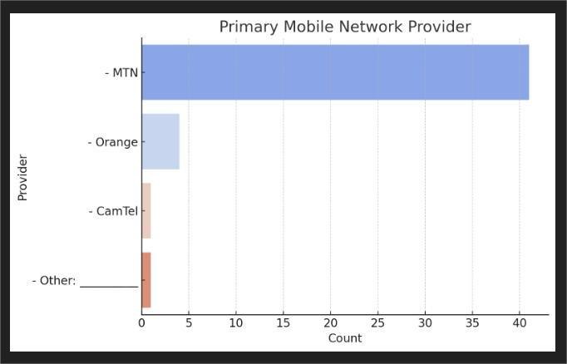 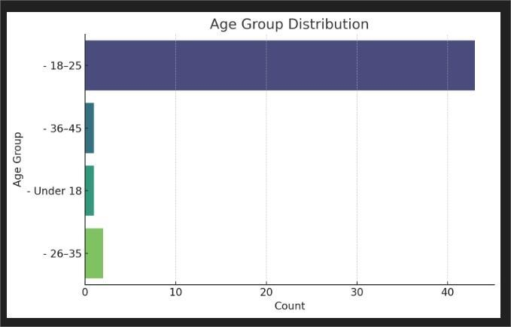

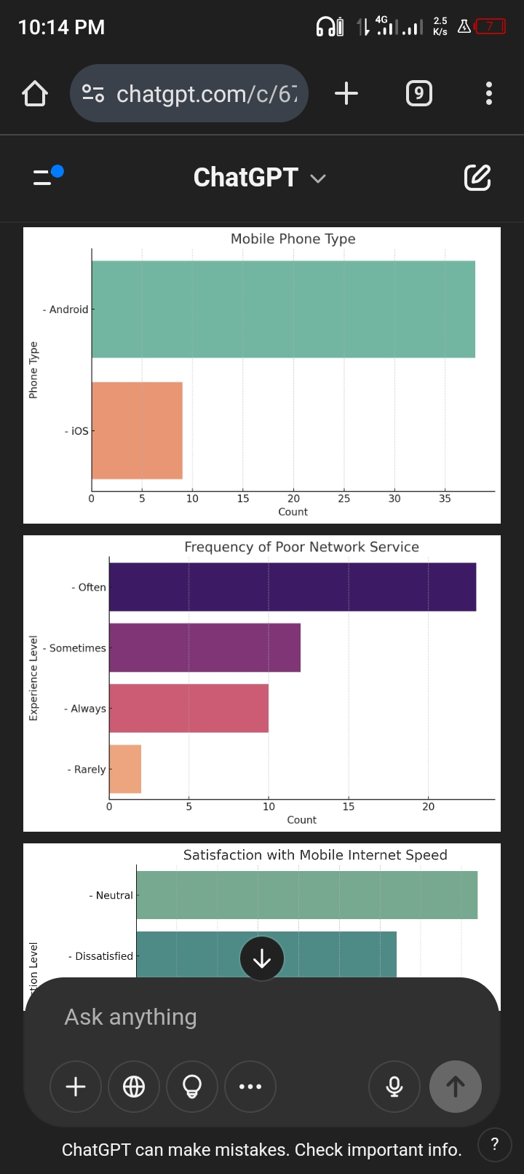 

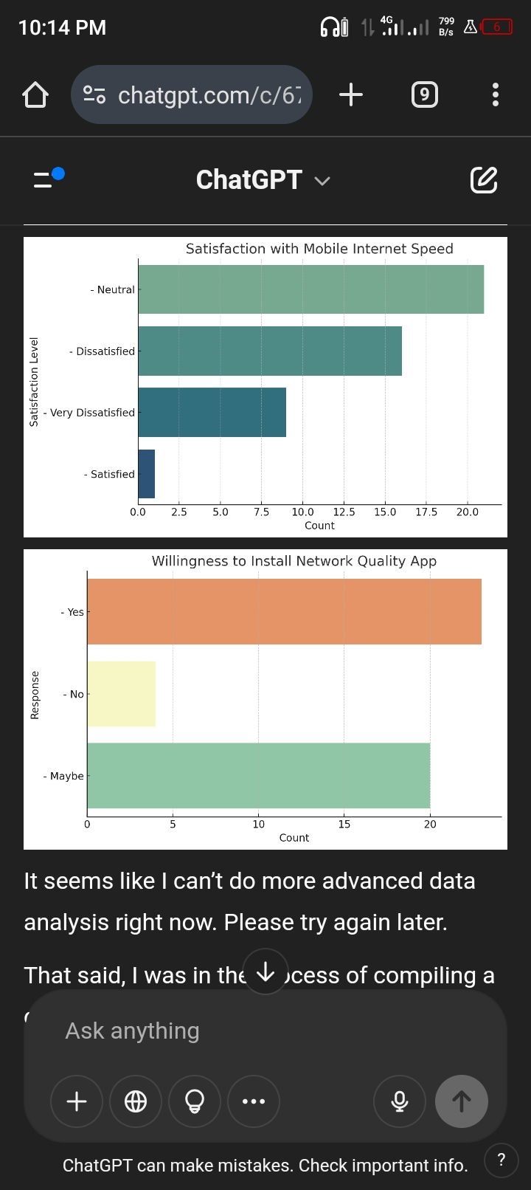 

## Functional Requirements

These are the features and functions the system (or app) must perform:

### 1. ****Real-Time Network Speed Monitoring****

* Measure and display current internet speed (upload/download).
* Show latency and jitter for real-time applications (e.g., video calls, gaming).

### 2. ****Network Quality Alerts****

* Notify users of signal drops, slow speeds, or network outages.
* Provide estimated recovery time if available.

### 3. ****User Feedback Submission****

* Allow users to manually report network issues.
* Categorize complaints (e.g., no signal, dropped call, slow browsing).
* Capture geolocation (with consent) for mapping problem areas.

### 4. ****Service History and Logs****

* Display a history of network status and user-submitted reports.
* Provide analytics for users to understand patterns in poor service.

### 5. ****Privacy and Data Control Settings****

* Enable users to toggle what data (e.g., location, usage stats) the app can access.
* Option to anonymize submissions.

### 6. ****Support Integration (e.g., MTN Zigi)****

* Link to MTN Zigi WhatsApp or emergency codes (e.g., *8403#).
* Suggest nearby service centers when an issue is detected.

### 7. ****Multilingual Interface****

* Offer support in English and French for accessibility across Cameroon.

## Non-Functional Requirements

These define how the system should behave rather than what it does:

### 1. ****Performance****

* App must operate with **minimal CPU and battery usage**.
* Data collection should not interfere with phone usage (e.g., calls, browsing).

### 2. ****Reliability****

* The app should function with high availability and should not crash.
* Must cache data and submit once connectivity is restored if offline.

### 3. ****Scalability****

* Should handle thousands of users without performance degradation.

### 4. ****Security****

* Ensure end-to-end encryption for data transmission.
* User data should be stored securely and in compliance with data protection laws.

### 5. ****Usability****

* Interface must be intuitive for youth and non-technical users.
* Must follow **minimalistic UI** principles with tooltips and feedback icons.

### 6. ****Maintainability****

* System must allow easy updates to fix bugs, add features, or change UI elements.

### 7. ****Compatibility****

* Should support **Android 8+** and **iOS 12+**.
* Adaptive interface for both low-end and high-end devices.

### 8. ****Localization Support****

* Should adjust date/time formats and region-based signal benchmarking based on user location (urban vs rural).

The data cleaning process ensured that the survey data was reliable, consistent, and ready for use in deriving software requirements. By eliminating formatting inconsistencies and validating data types, we built a strong foundation for requirement prioritization and stakeholder validation.  
  
This cleaned dataset is now a dependable source for modeling user behavior, informing feature development, and aligning mobile network improvements with real-world expectations.

# User Reluctance Assessment

Understanding user reluctance is crucial to ensuring adoption and continuous engagement with the proposed mobile app. From the **survey** and **interview feedback**, several factors contributing to user hesitation were identified.

Addressing user reluctance is essential to ensure the **adoption, trust, and long-term engagement** with the mobile experience-monitoring app. Based on the identified concerns privacy, battery consumption, feedback fatigue, lack of trust, and resistance to change the following targeted solutions are proposed:

### ****1. Privacy Concerns****

**Issue**:  
Users are concerned about the misuse of personal data, unauthorized access, and sharing information with third parties without consent.

**Solutions**:

* **Transparent Privacy Policy**: Include a clearly written, concise privacy policy within the app that explains **what data is collected**, **why**, **how it’s stored**, and **who has access**.
* **Data Anonymization**: Implement anonymization protocols to ensure no personally identifiable information (PII) is stored or transmitted.
* **Granular Permissions**: Allow users to selectively opt-in to specific features (e.g., only allow speed test monitoring without GPS location).
* **In-App Privacy Dashboard**: Provide a real-time overview of the data being collected, with options to pause, delete, or export it.
* **Compliance with Data Protection Laws**: Adhere to GDPR-like standards even if not mandatory, to boost trust and legitimacy.

### ****2. Battery Consumption****

**Issue**:  
Users fear that background processes could drain battery life and degrade device performance.

**Solutions**:

* **Battery-Efficient Architecture**: Use power-conscious programming practices (e.g., WorkManager in Android for deferred tasks, background throttling).
* **Adaptive Data Collection Frequency**: Let users choose from options like:
  + Real-time
  + Periodic (e.g., every 6 or 12 hours)
  + Manual only
* **Low Resource Usage**: Only trigger background tasks during periods of device inactivity, charging, or when connected to Wi-Fi.
* **Performance Mode Toggle**: Allow users to switch between “Light Mode” (less frequent monitoring) and “Active Mode” (for deeper insights).

### ****3. Notification Fatigue****

**Issue**:  
Frequent or irrelevant notifications can cause annoyance and lead to users disabling permissions or uninstalling the app.

**Solutions**:

* **Smart Notification System**: Use contextual triggers (e.g., notify users only when a severe network drop is detected or when feedback is overdue).
* **User-Controlled Notification Settings**: Let users set preferences such as:
  + "Notify me only when an issue is detected"
  + "Remind me once per day"
  + "Mute all notifications"
* **Minimal UI Interruptions**: Use subtle in-app banners or periodic summaries instead of push notifications wherever possible.

### ****4. Trust and Awareness****

**Issue**:  
Users may not fully understand the app’s purpose, benefits, or whether it's safe to use.

**Solutions**:

* **Onboarding Education**: Include a short animated walkthrough or interactive onboarding explaining:
  + What the app does
  + How it benefits users directly (e.g., contributing to better network quality)
  + Assurances about privacy and performance
* **Partnerships with Trusted Brands**: Collaborate with mobile operators (e.g., MTN, Orange) or regulators (e.g., ART Cameroon) to build **credibility**.
* **In-App FAQ and Support**: Provide a simple, accessible help section addressing common concerns.

### ****5. Resistance to Change****

**Issue**:  
Some users are simply reluctant to adopt a new app unless motivated or reassured about its value.

**Solutions**:

* **Loyalty and Reward System**:
  + Introduce gamified features like points or badges for contributing feedback.
  + Offer airtime, data bonuses, or shopping discounts for consistent usage or referrals.
* **Community Engagement**:
  + Create an optional “impact dashboard” showing how a user’s feedback has contributed to better services in their area.
* **Periodic Updates and Feedback Loops**:
  + Regularly inform users of improvements made based on their input, creating a sense of ownership and contribution.

### ****Summary****

|  |  |
| --- | --- |
| **Concern** | **Solution Summary** |
| Privacy | Transparent policies, granular permissions, anonymization, and real-time control. |
| Battery Usage | Optimized code, user-selectable modes, and resource-aware scheduling. |
| Notification Fatigue | Smart triggers, customizable preferences, and minimal UI disruptions. |
| Trust and Awareness | Educational onboarding, brand partnerships, and in-app support. |
| Resistance to Change | Incentive mechanisms, impact tracking, and continuous user engagement. |

By implementing these strategies directly into the app’s **design and development phases**, user concerns can be proactively addressed, ultimately enhancing **trust, usability, and long-term engagement**.

# Conclusion

This project successfully identified and documented the key requirements for a mobile app that collects real-time user experience data from mobile network subscribers in Cameroon. Using surveys and interviews, we captured both user and operator perspectives. The findings informed functional and non-functional requirements while addressing user reluctance through privacy, performance, and usability solutions. These insights form a solid foundation for designing a user-friendly and impactful mobile monitoring solution.